**APPENDIX**

**Please note that I did a lot of queries, all of them can founded in the code software.**

**I included here the most used queries for my analysis.**

**Please take your time to look for the rest of the codes with the respective comments in the SQL code**

**FINANCIAL**

**query #2 :** **Yearly and monthly sales evolutions**

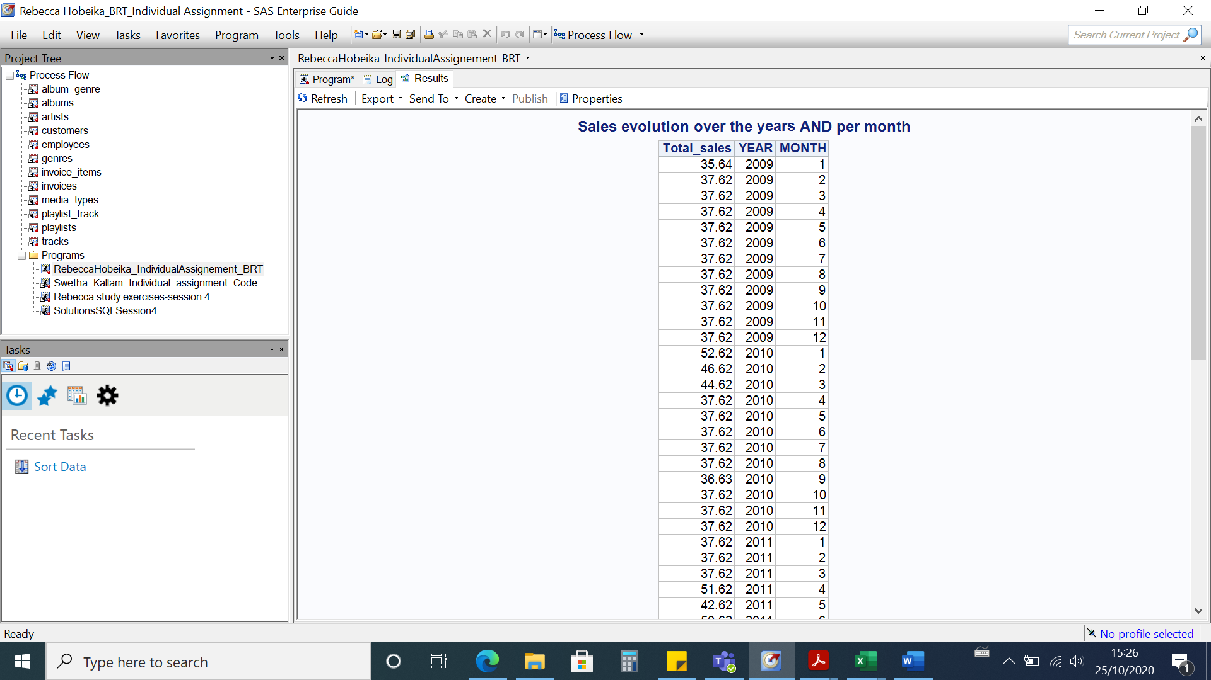

**query #4 :** **Evolution over the years and difference of sales from 1 year to another**

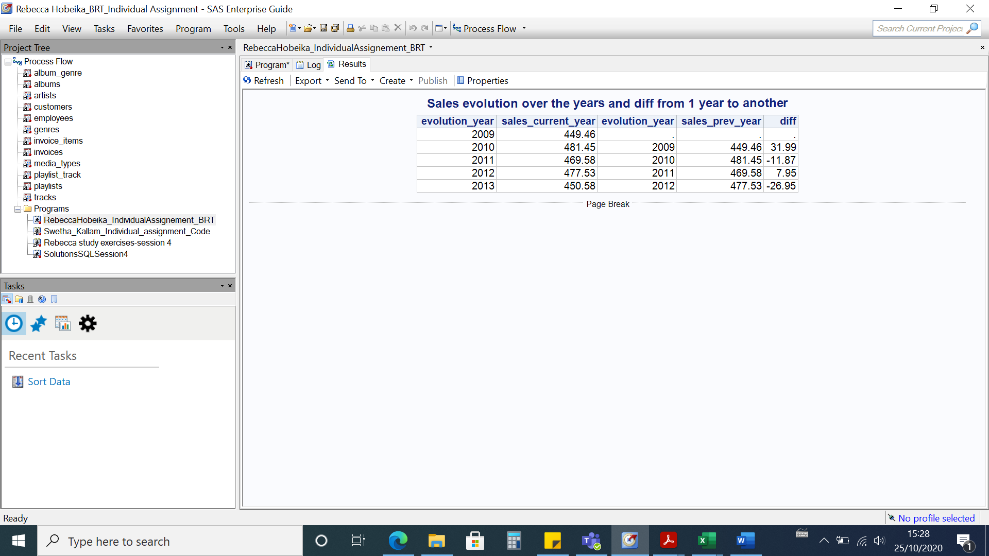

**query 6:** **Yearly evolution of average number of tracks per invoice**

**query #5 : Number of purchases (tracks) per invoice for all purchases**

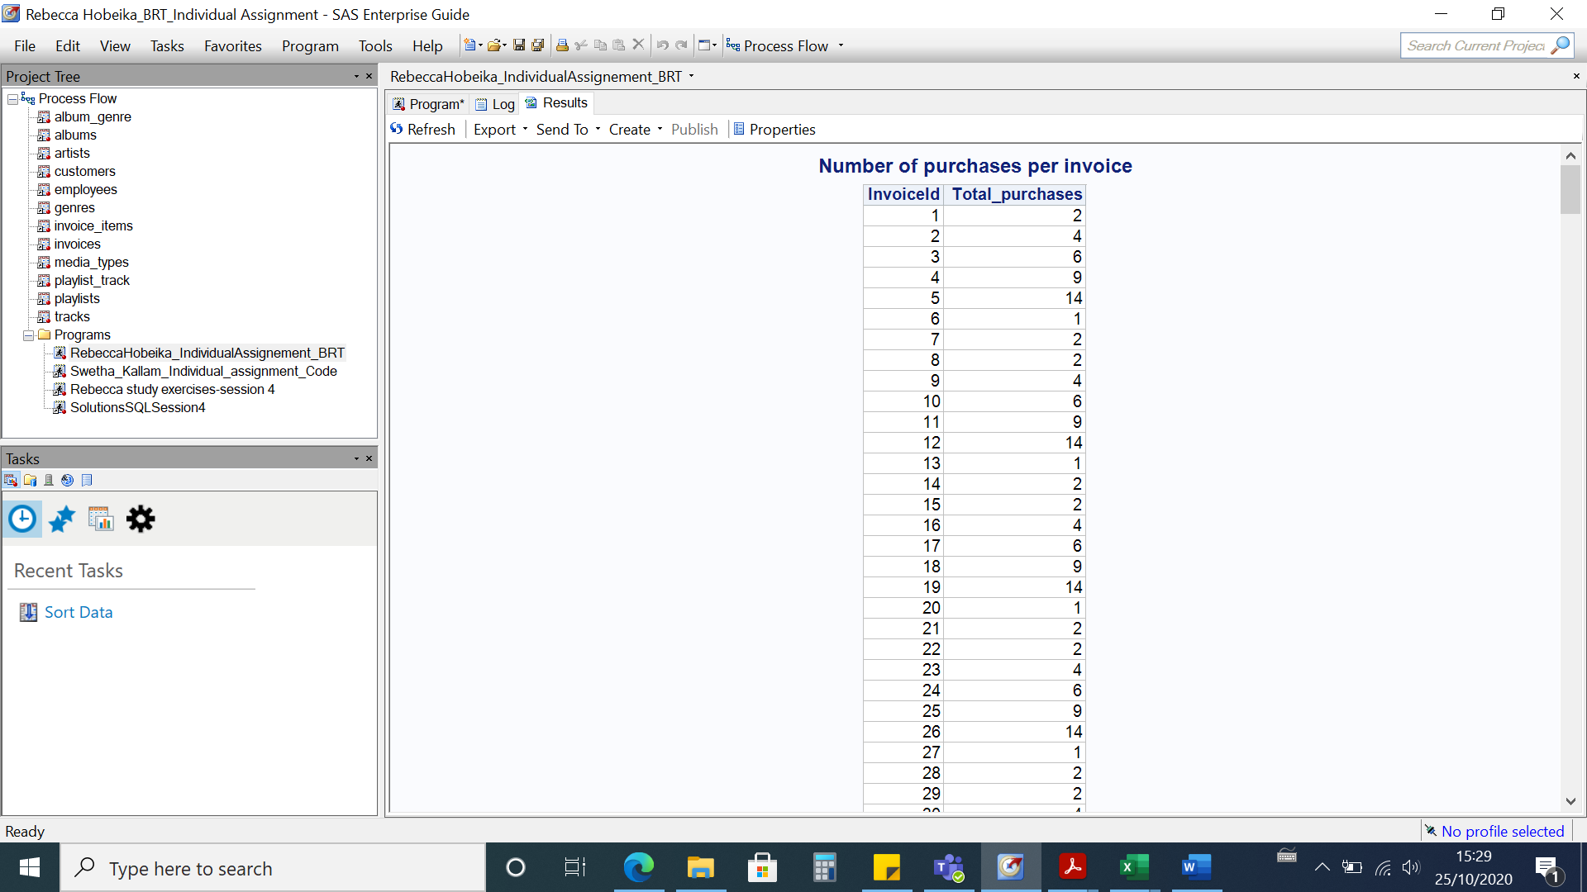

**CUSTOMERS**

**query #15: In which markets did we sell each. Did we enter a new market in the last 3 years ?**

**query #16:** **How many of our customers made a purchase in the last 3 months?**

**query #10: What is the percentage of customers purchased at least twice in the last 2 years**

**query #8: How many customers do we have? Are they company clients or not?**

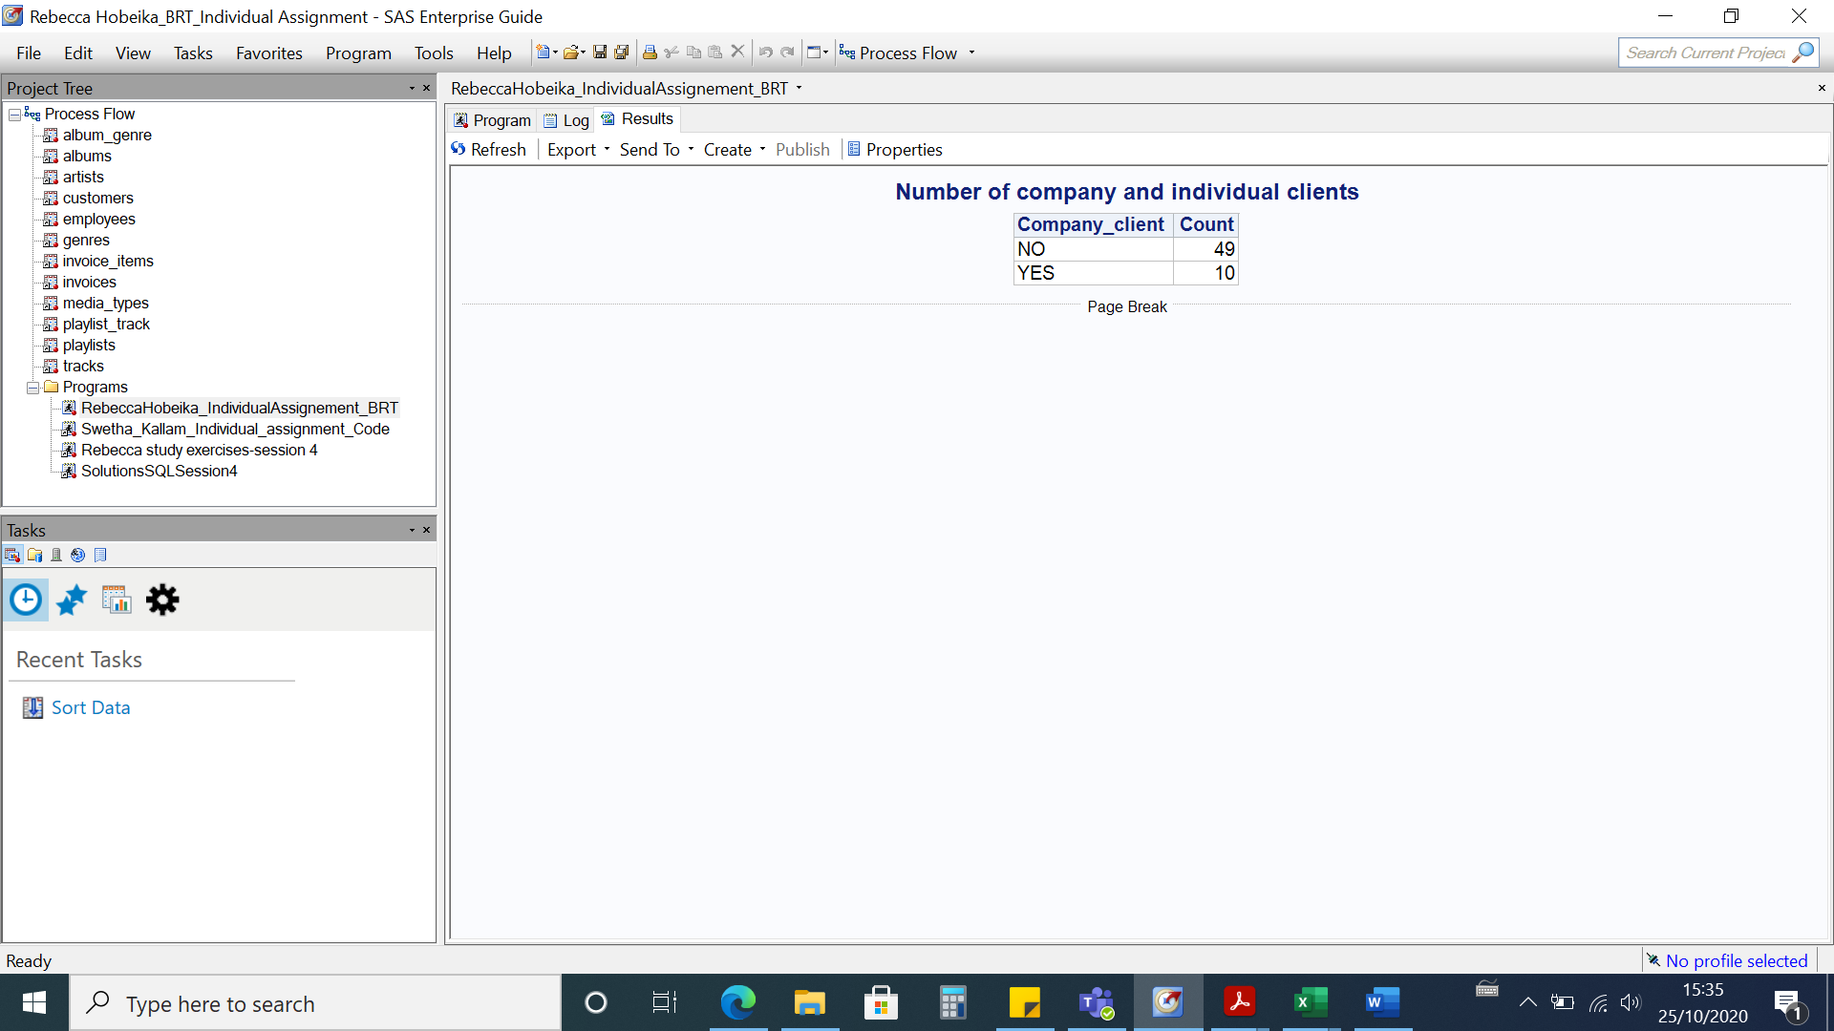

**query #9: Recency, frequency, tenure and average sales per order for each customer**

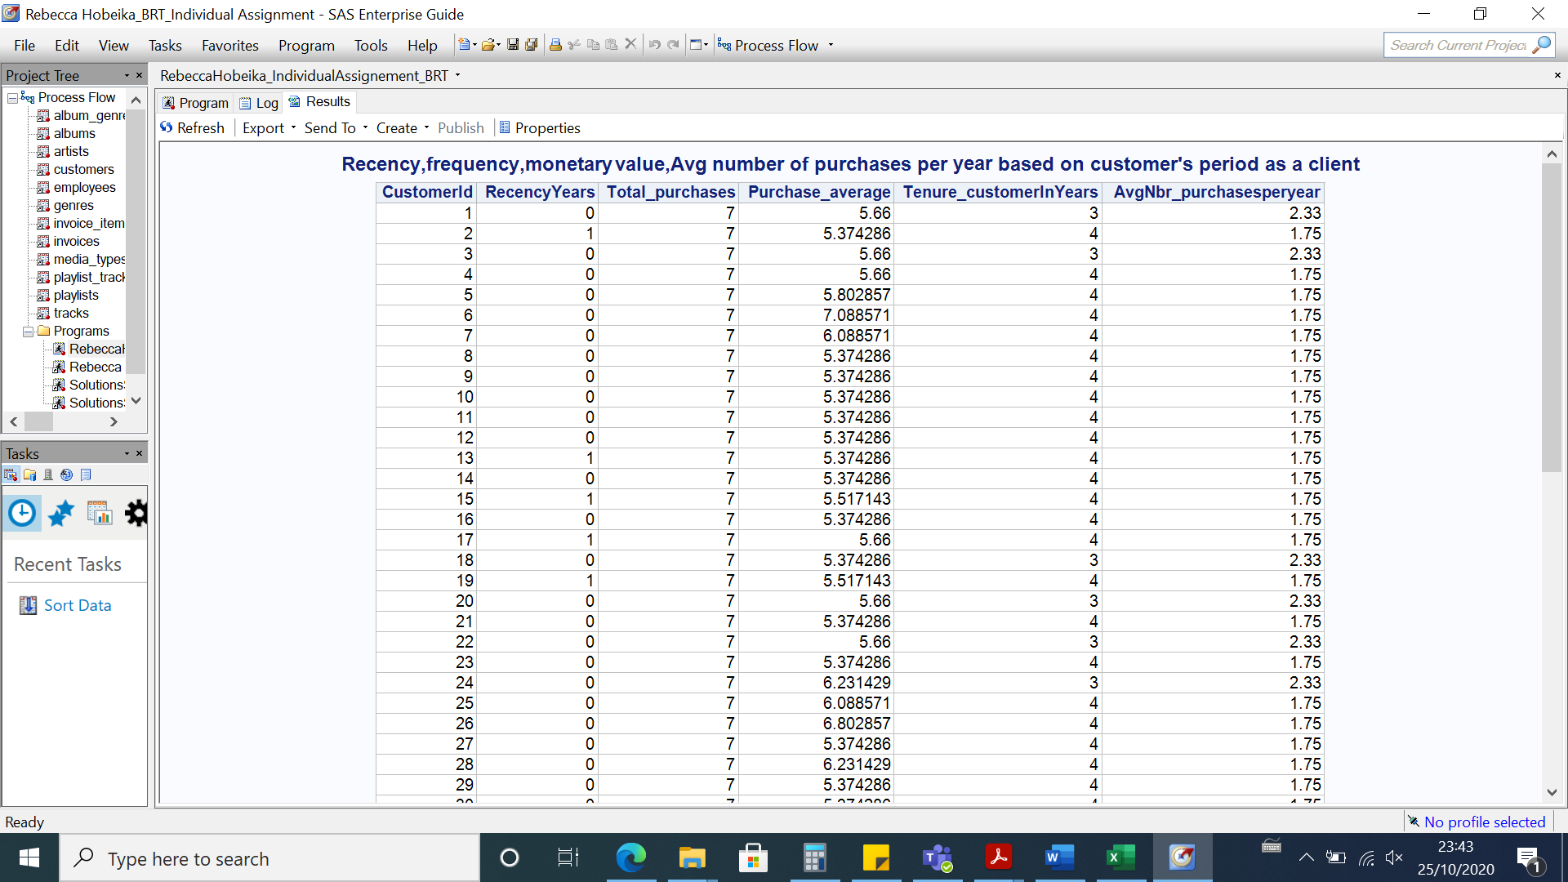

**query #12: Size of each market in total sales and number of customers**

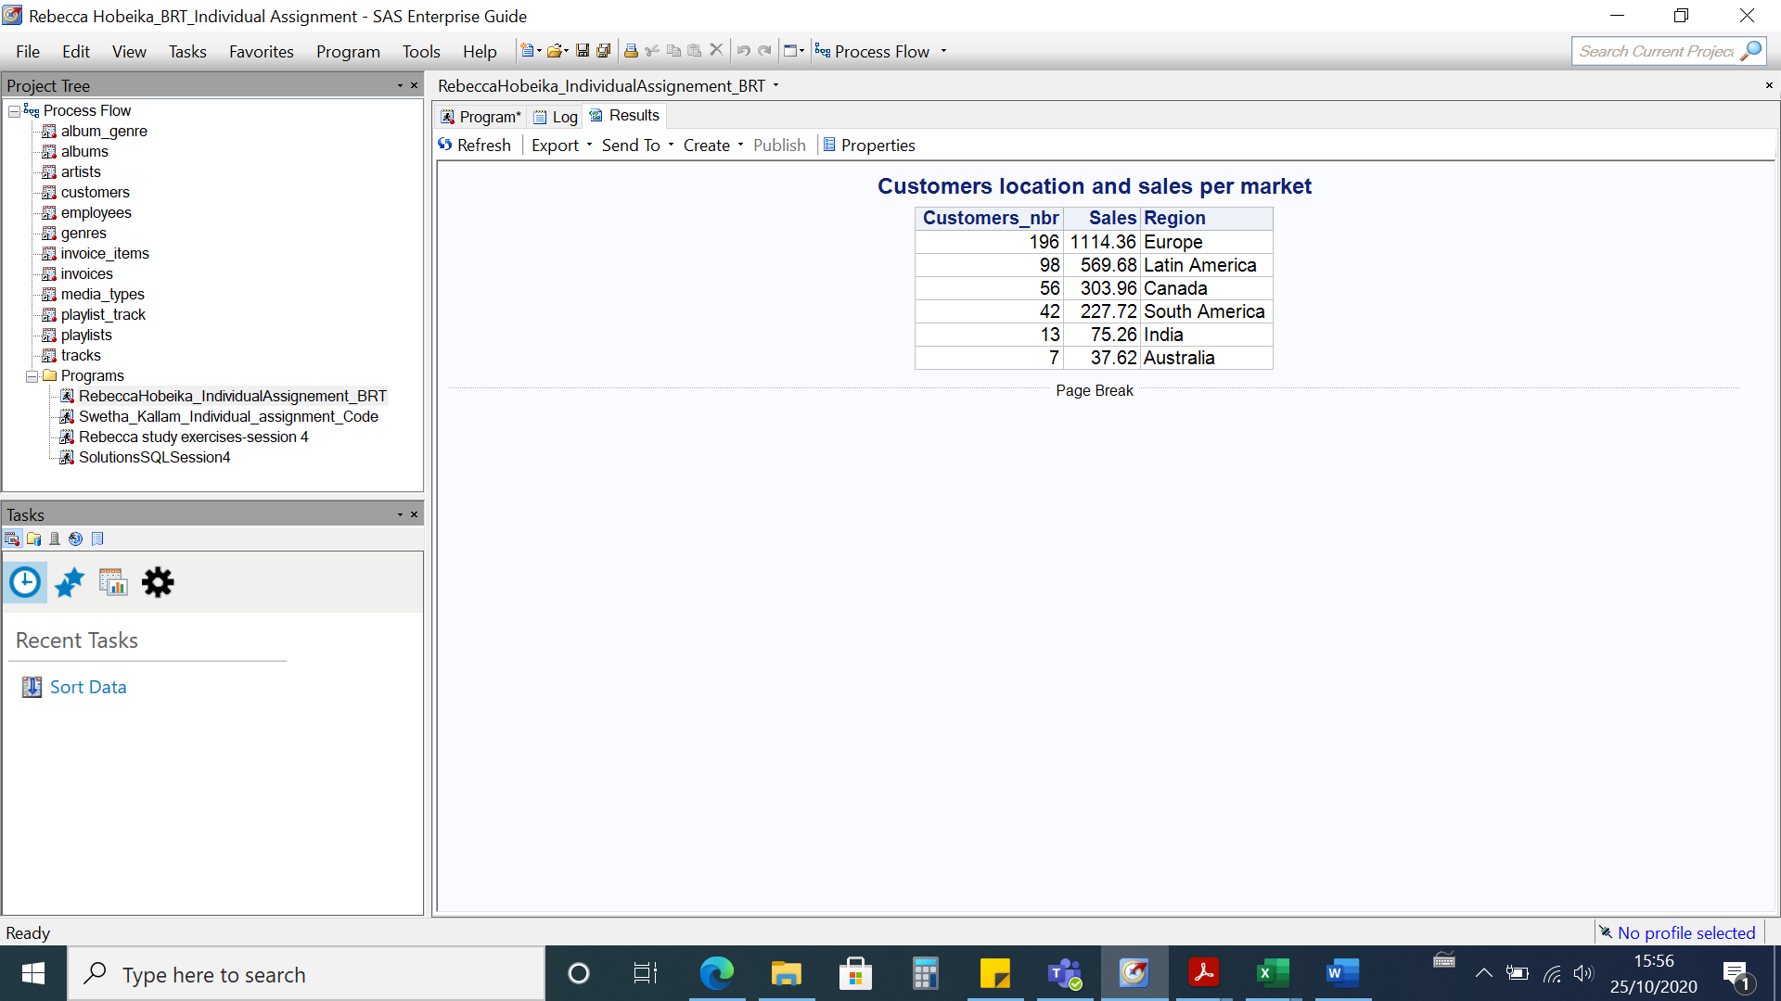

**INTERNAL BUSINESS PROCESS**

**query #32: number of markets for each salesperson**

**query #33: number of products that haven’t been sold in the last 1 year**

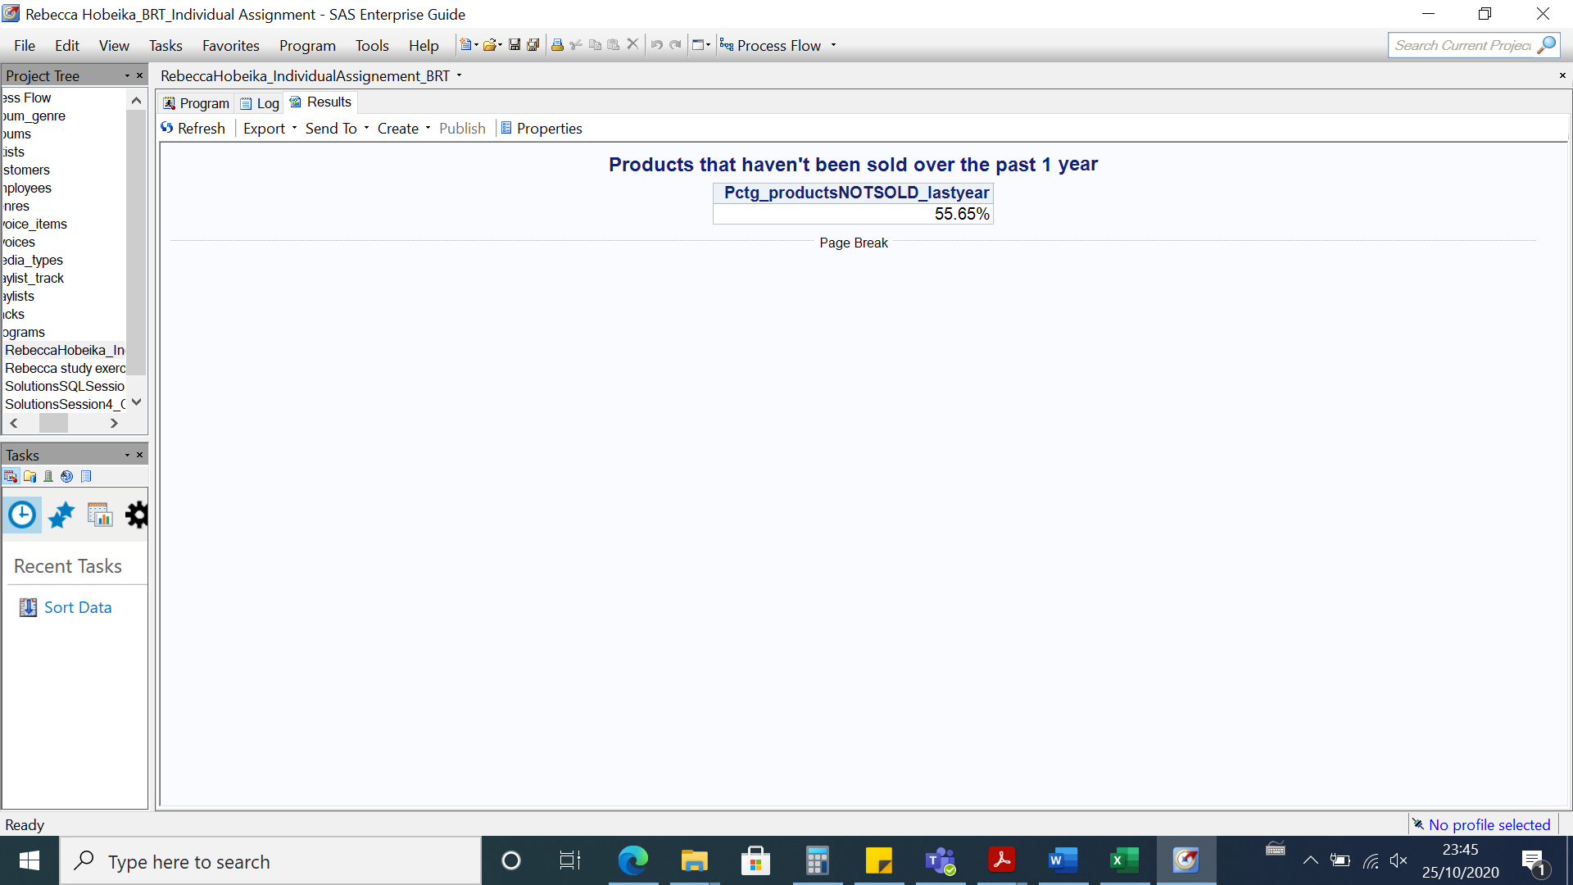

**query #26: percentage of tracks belonging to high performing genres**

**query #18: Number of sales per genre type**

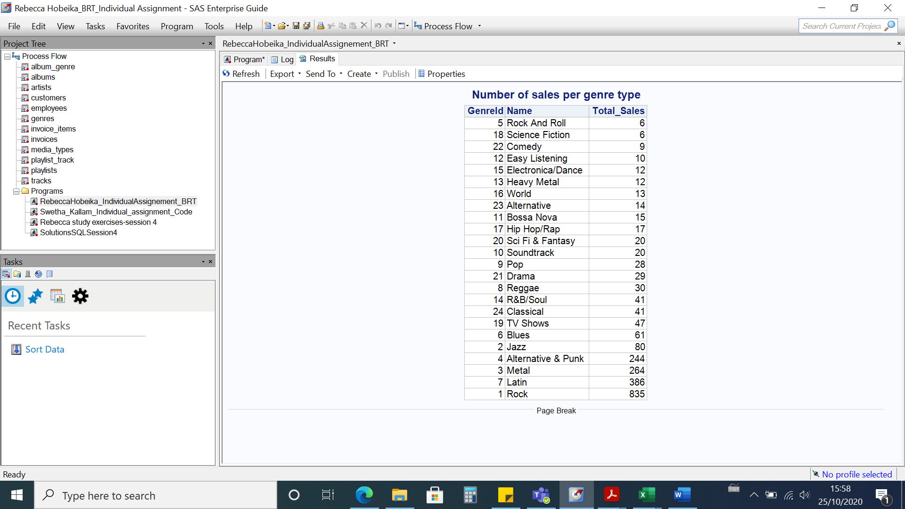

**query #19: Genre that sold the most**

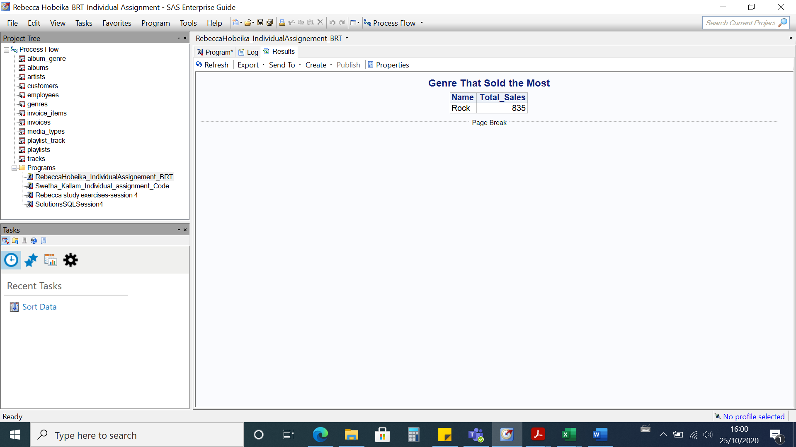

**query #20: Genre that sold the least**

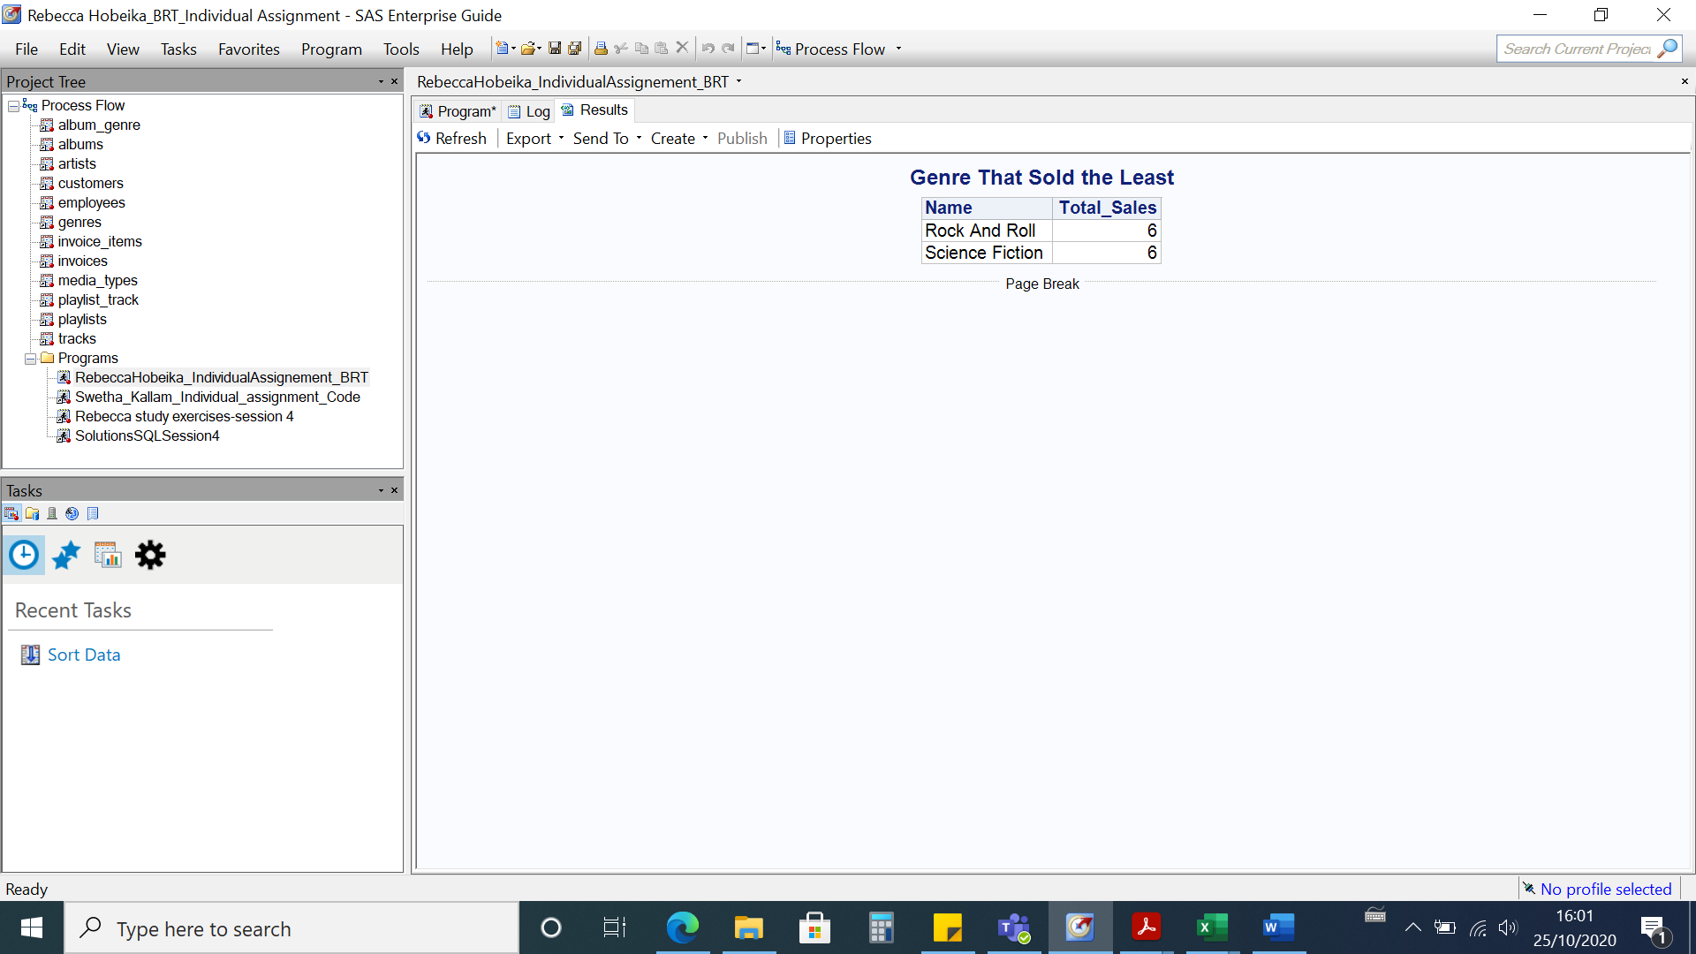

**query #21: Mediatype sold the least**

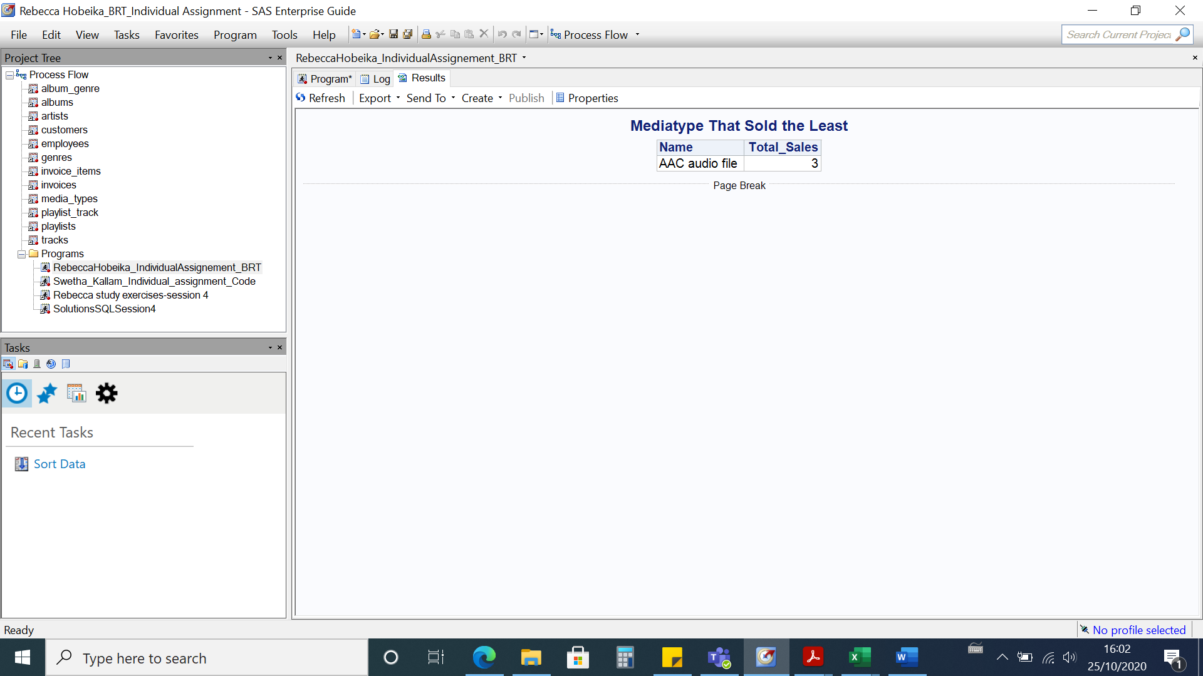

**query #22: Mediatype sold the most**

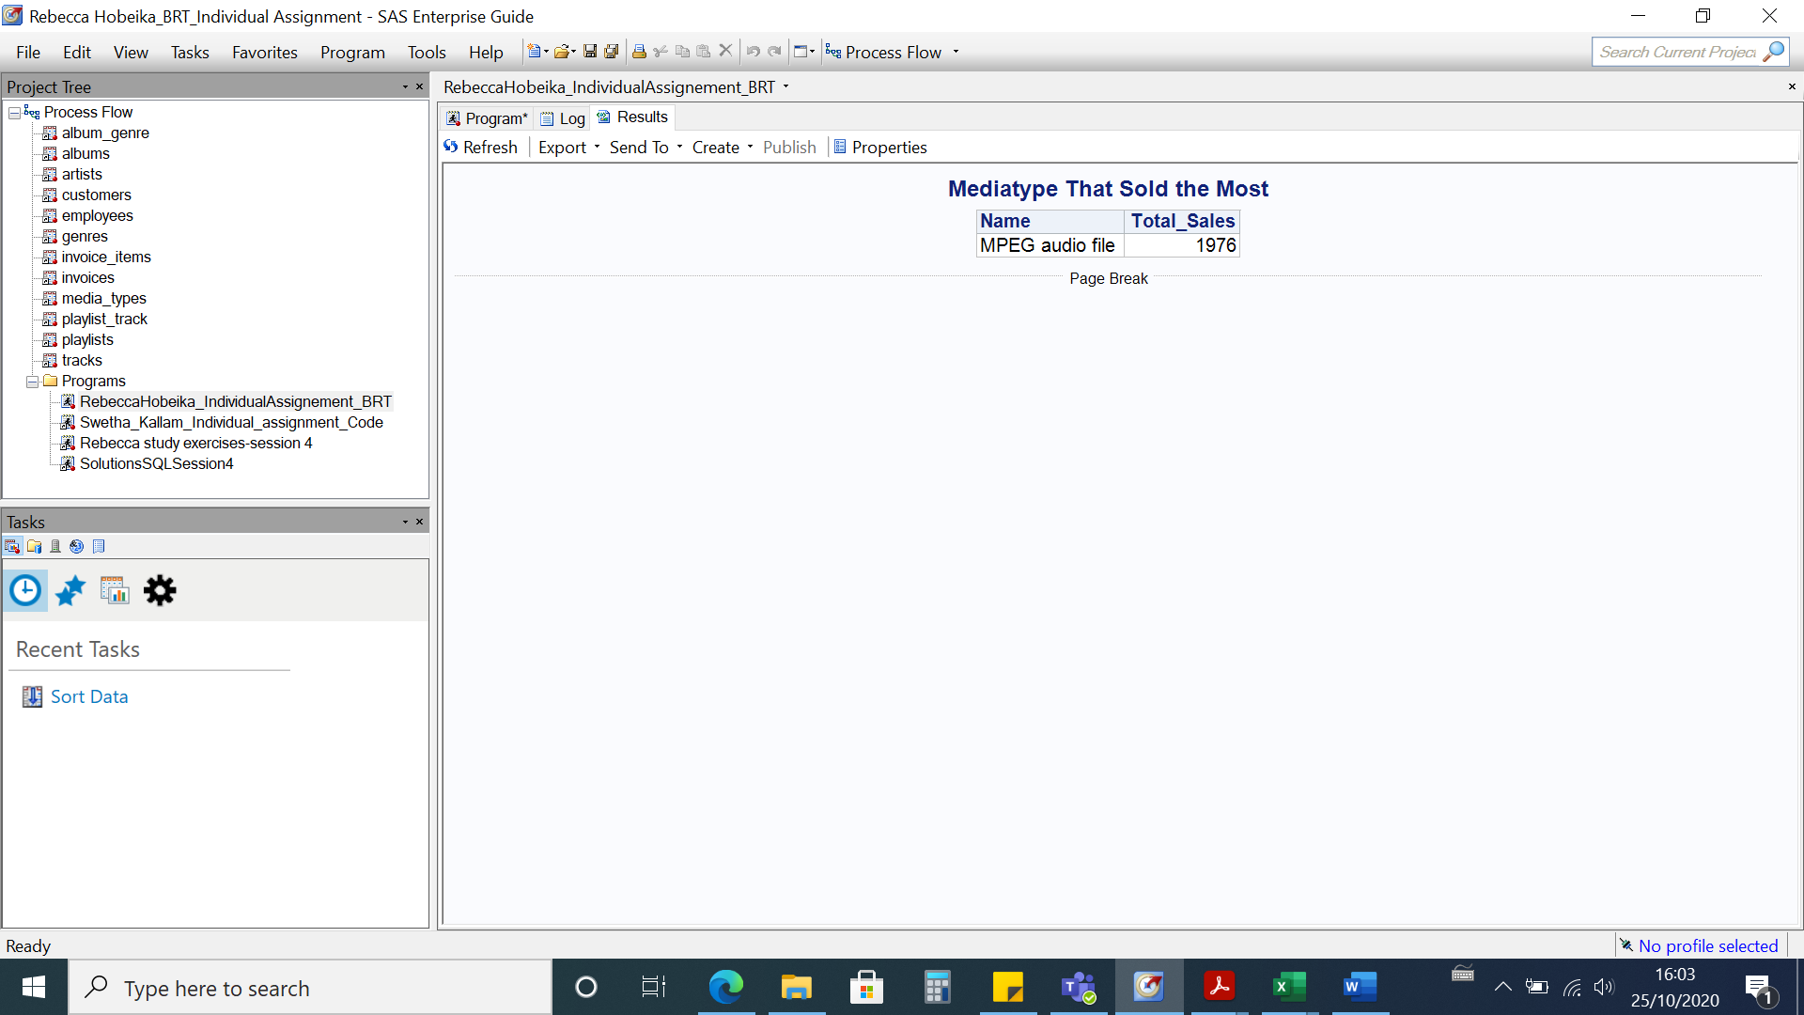

**query #25: Genre sales and performance**

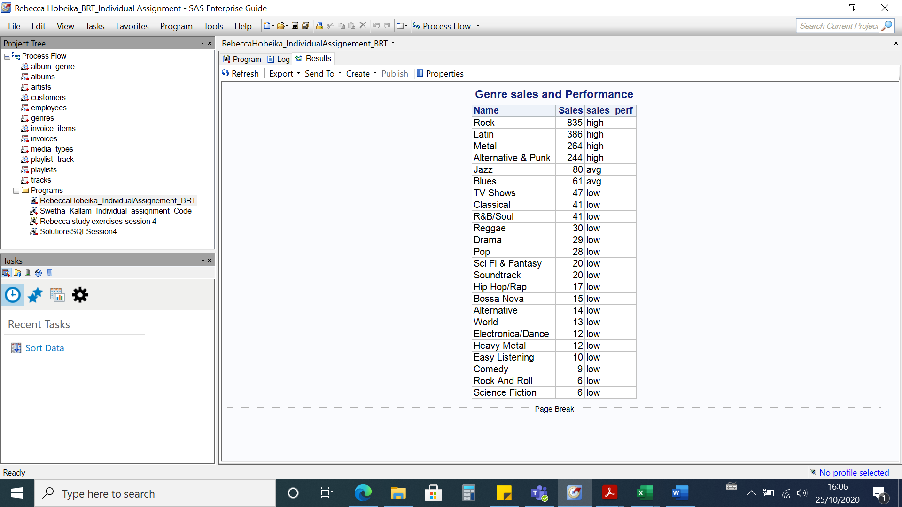

**query #26: Percentage of tracks out of total tracks that belongs to high performance genre**

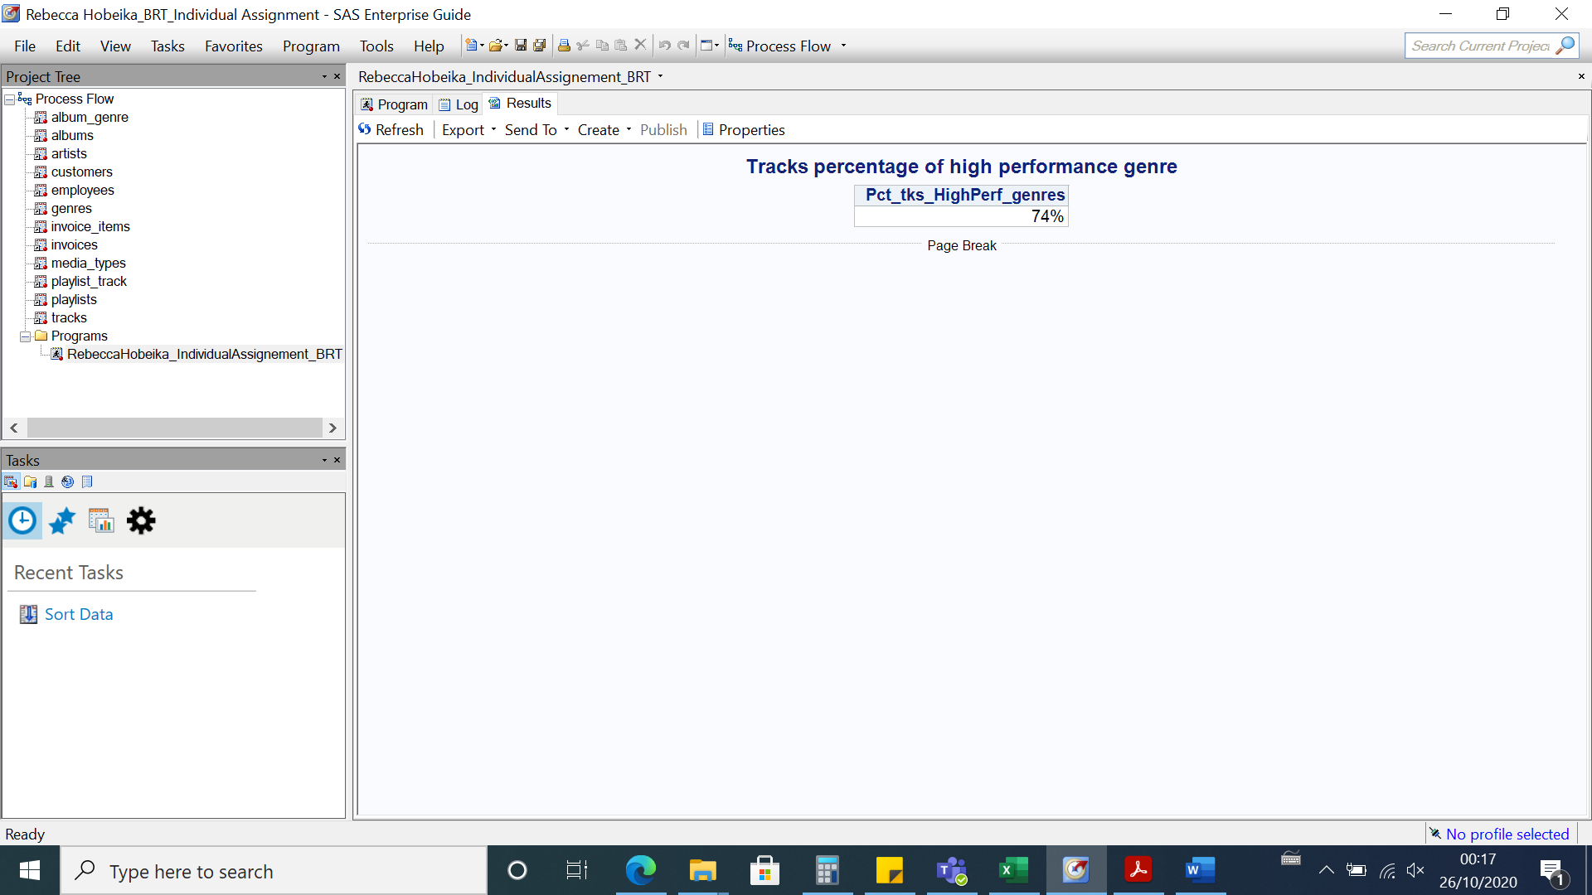

**query #27: Percentage of tracks per genre**

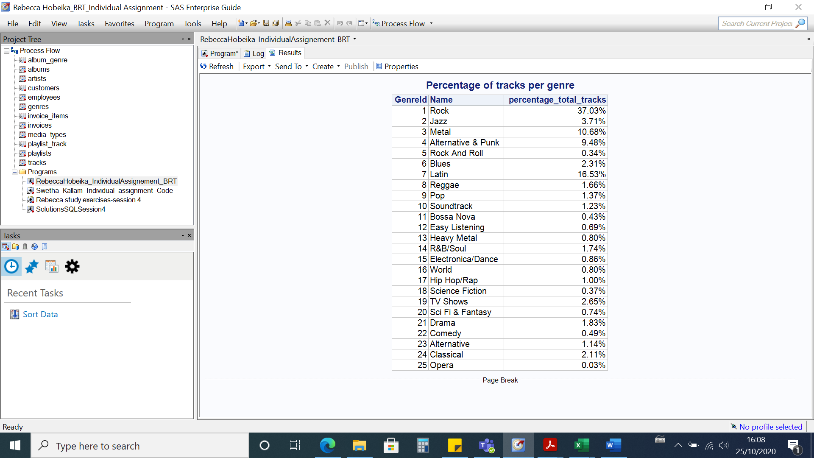

**query #28: Tracks and total sales**

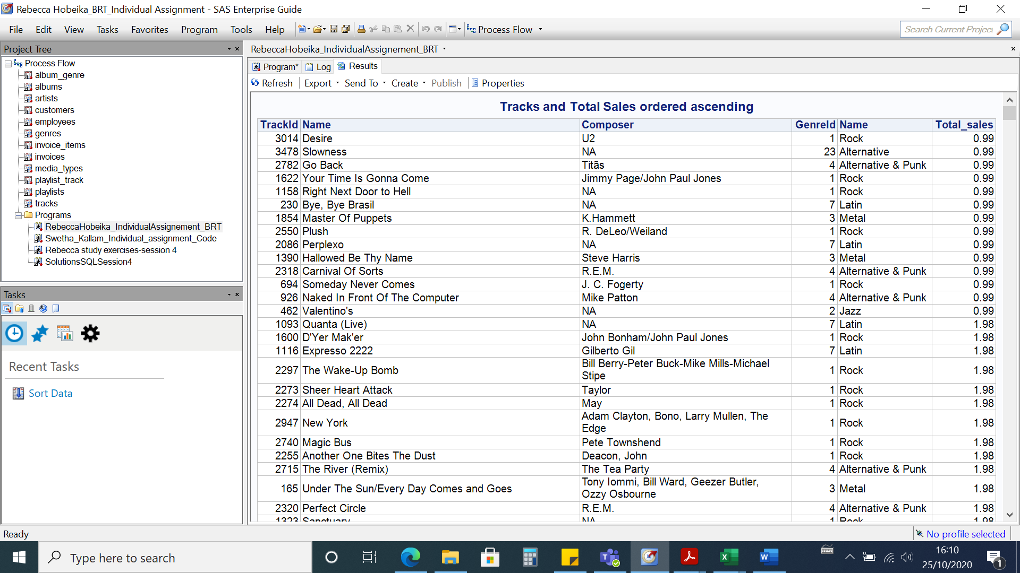

**Query #34:Percentages of how many songs customer has bought from a specific artist out of all his purchases**

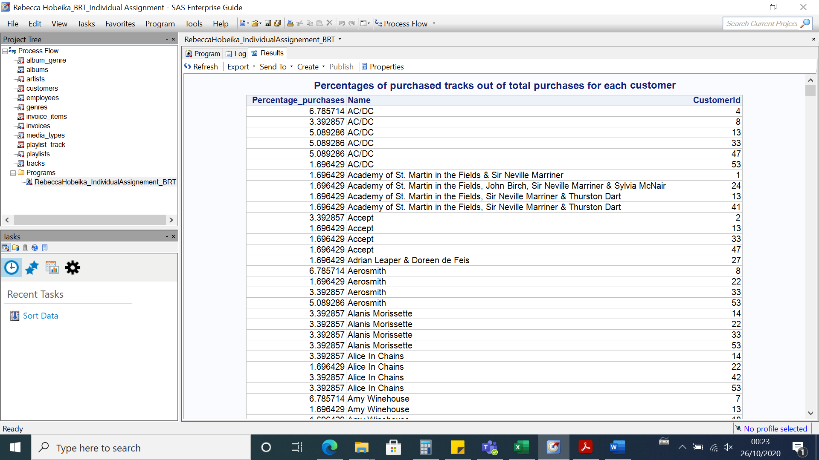

**-EMPLOYEES:**

**Query #35: How many employees do we have**

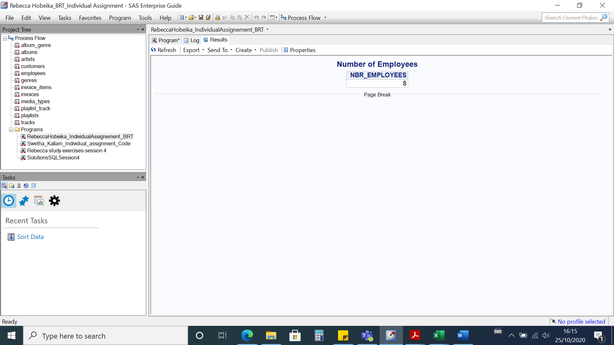

**Query#37 : how many are about to retire (age > 60), how long are they in the company?**

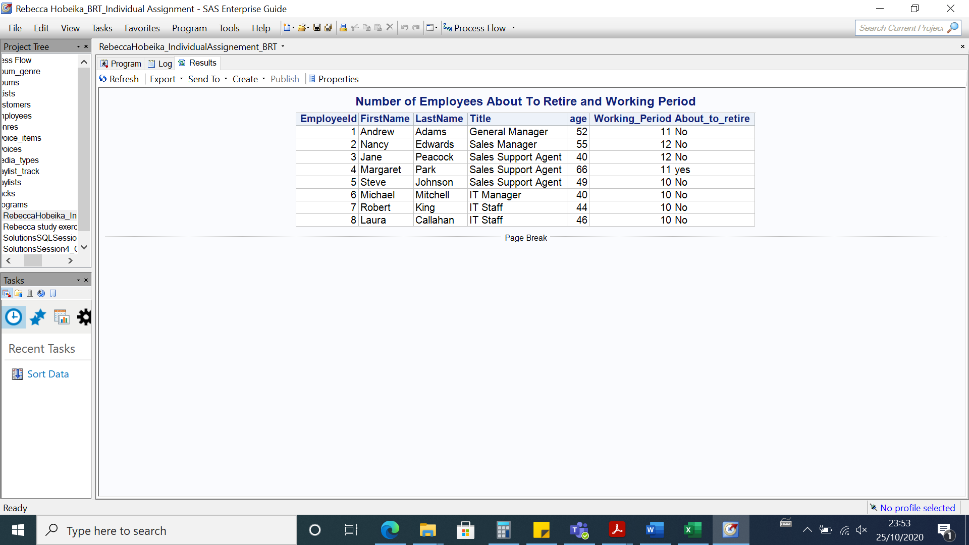

**Query#38 : How are the company employees distributed based on their age**

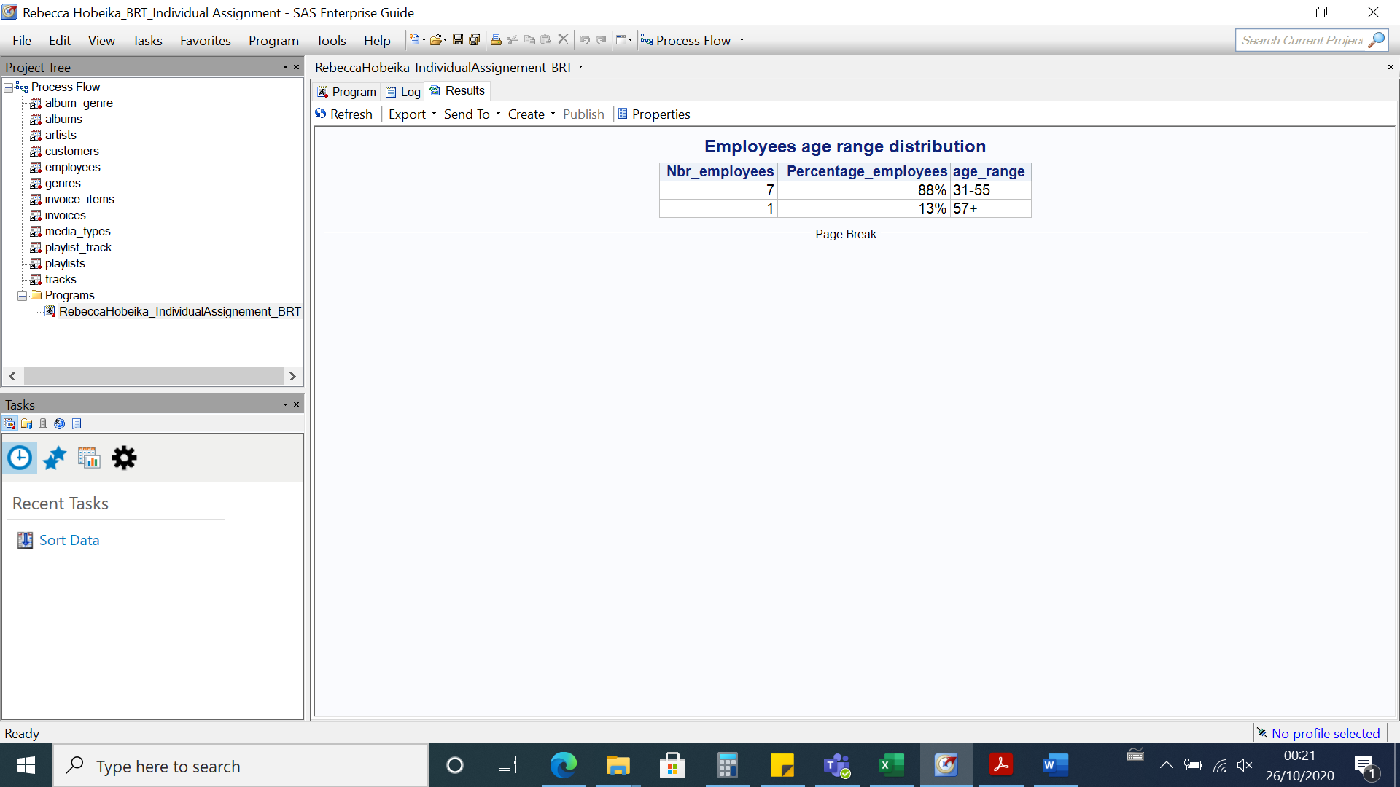

**Query#39 : How are the company employees distributed based on the department**

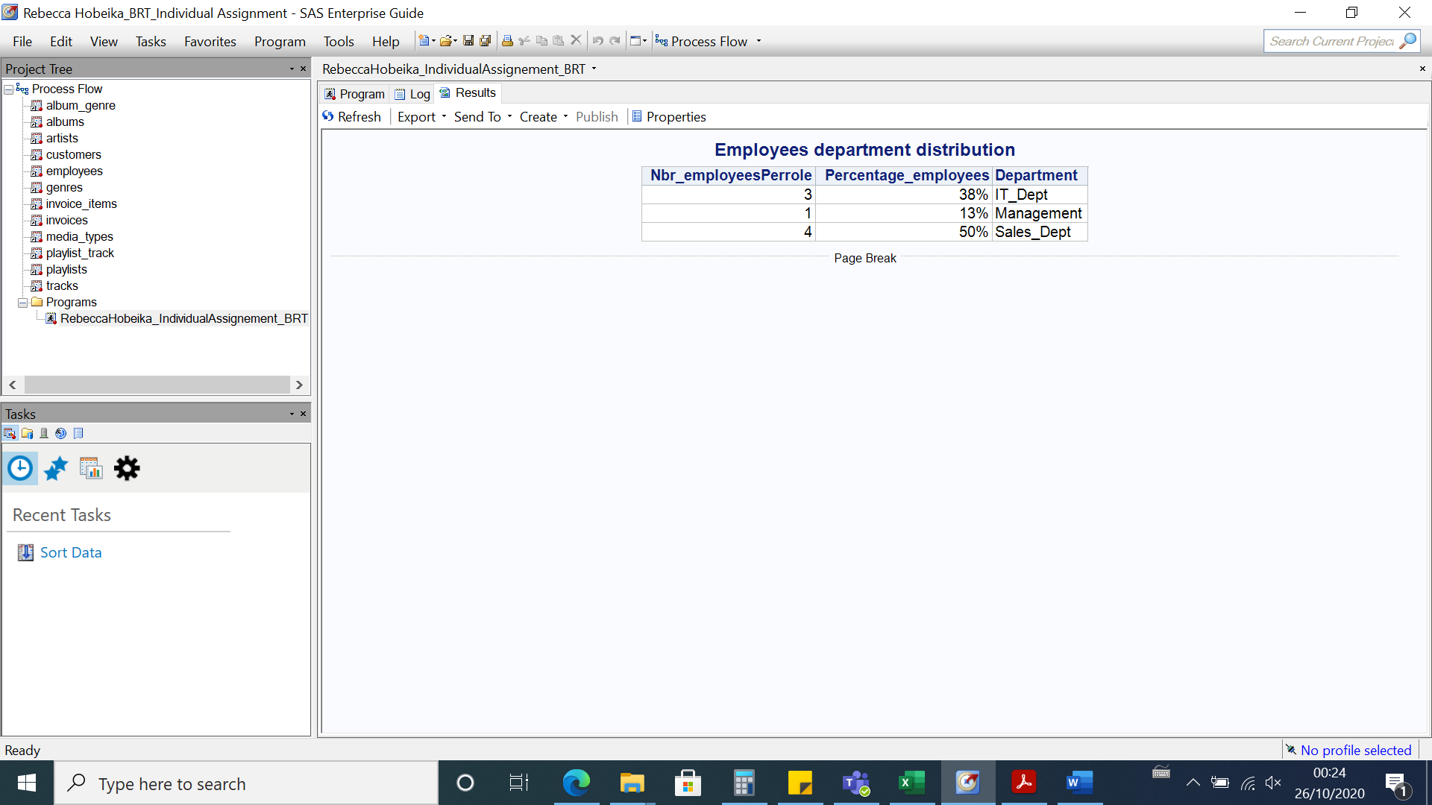

**Query#41 : Employees Recruitment status Over The Last 2 Years**

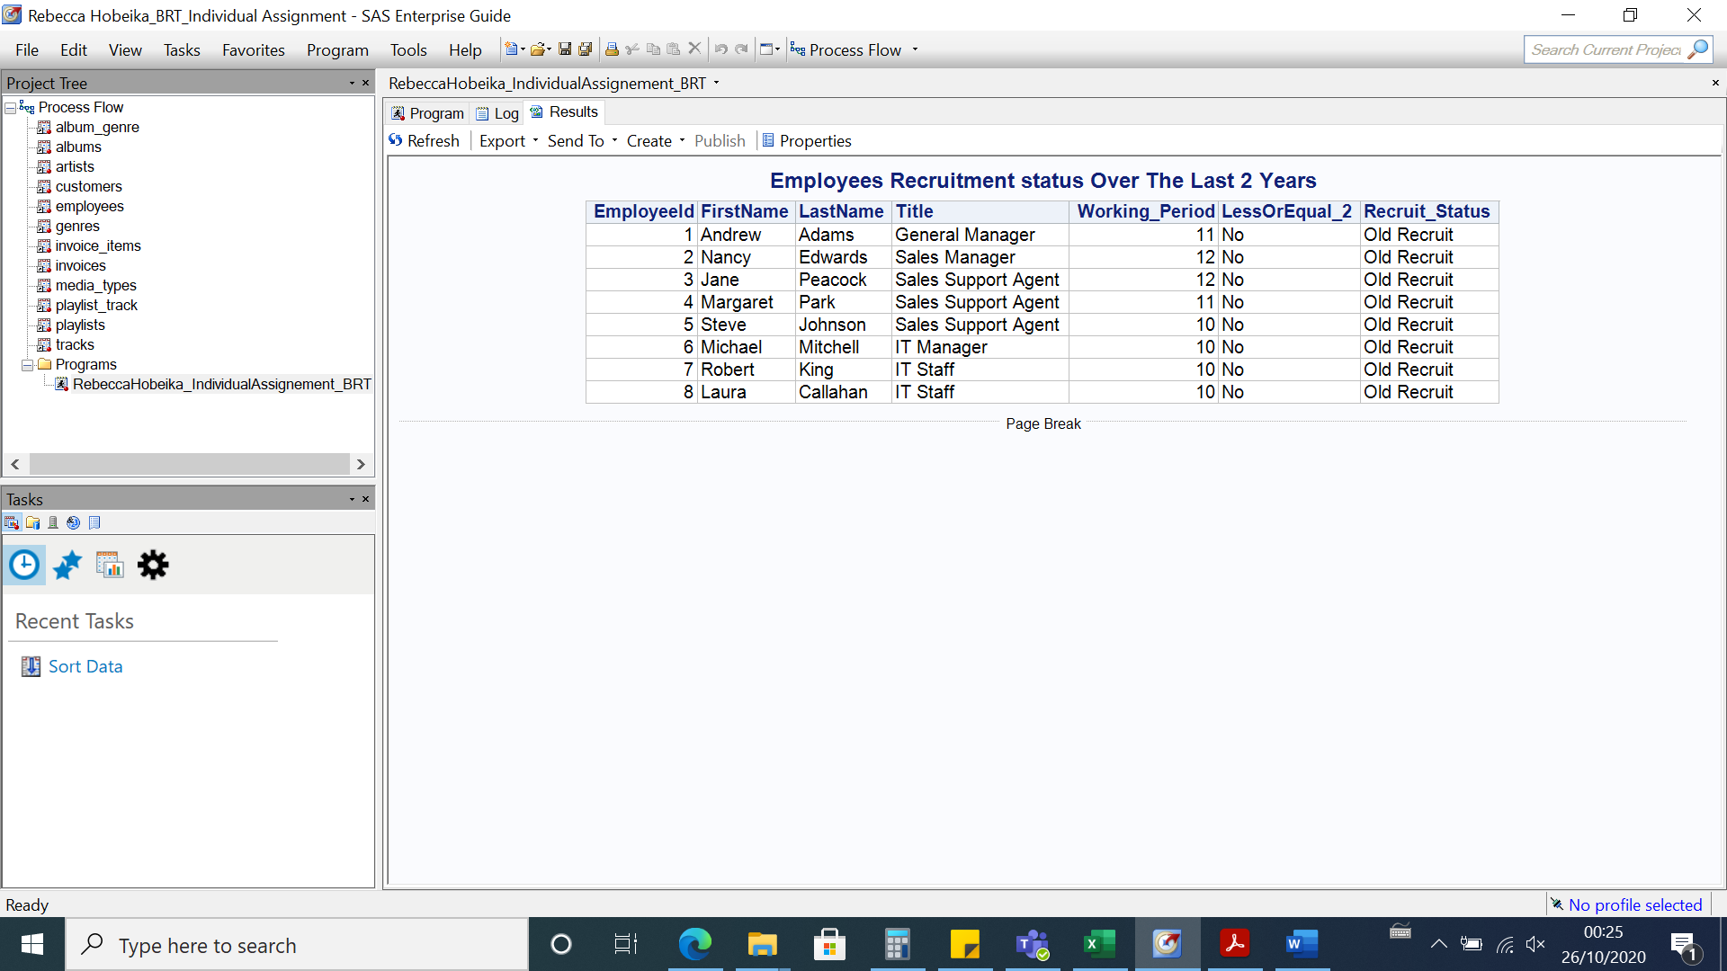

**Query#42: Percentage of people with working period greater than or less than or equal 10 years**

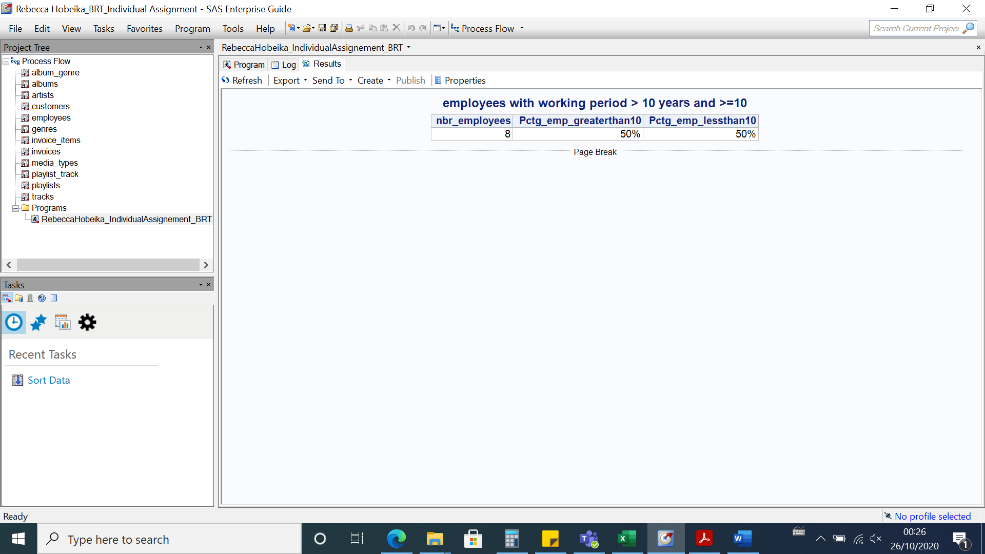

**Query#44 How many different roles do we have?**

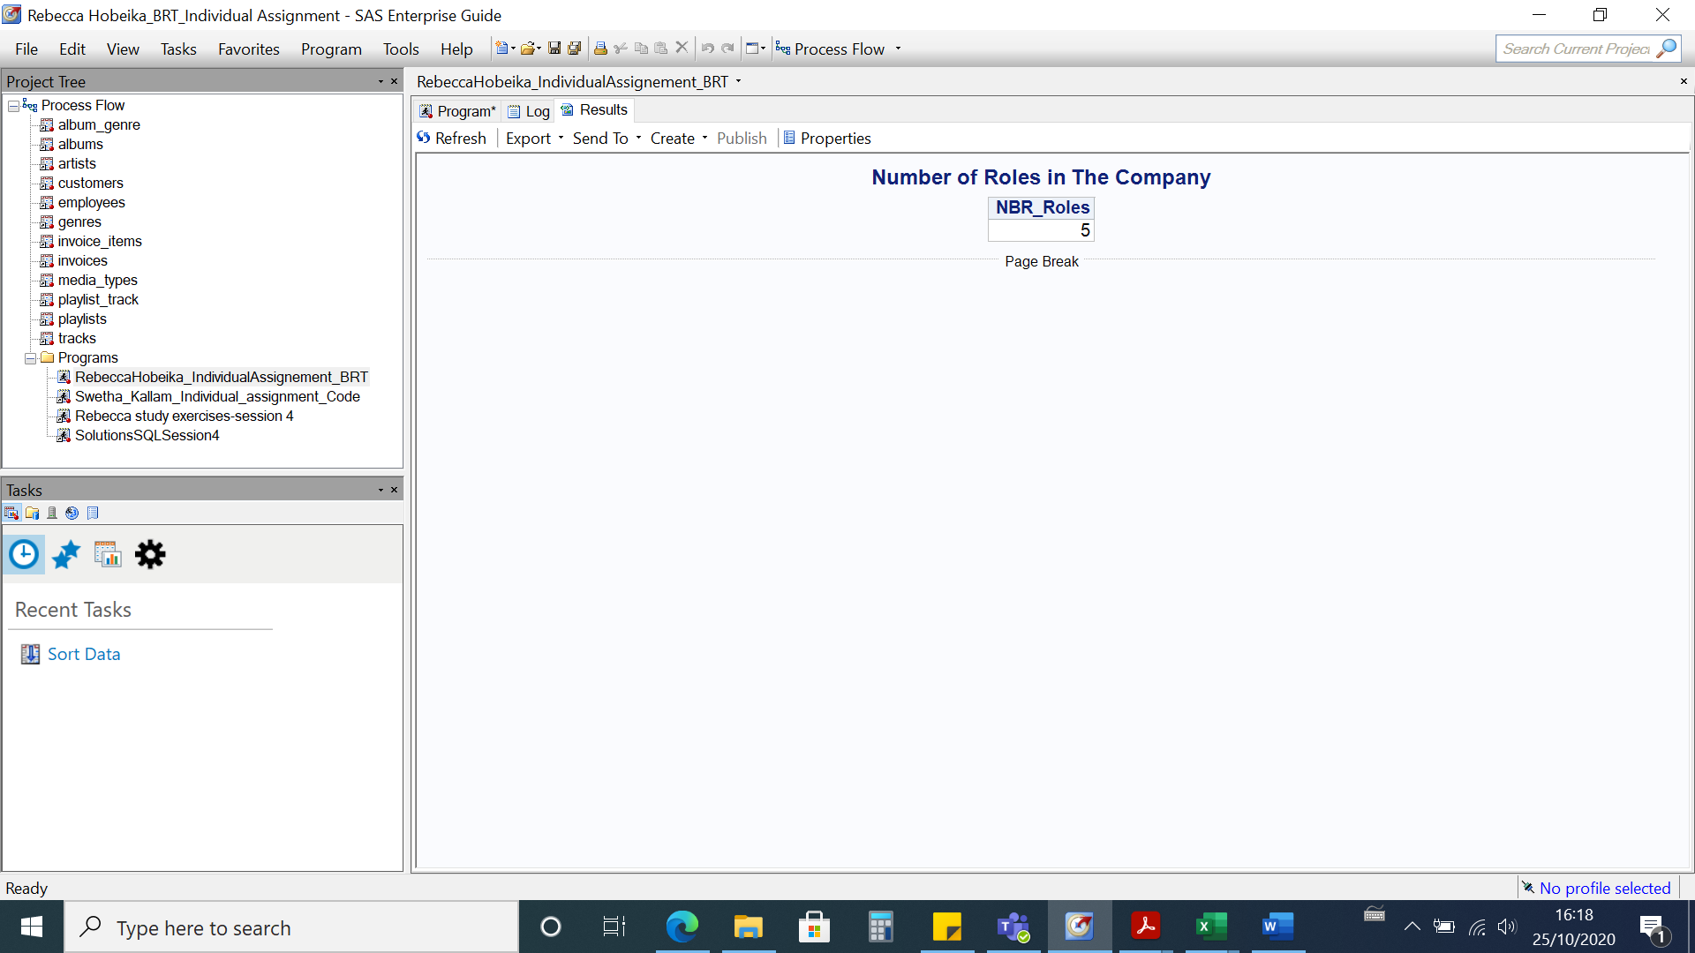

**Query#45:How many sales does each of the salespeople have? What areas do they serve?**

